**Analytics Findings:**

1. In order to make sure that maximum number of users requests are fulfilled we have combined data from various sources and transformed them into on single source data. This will help data analysts and scientists to pull only a single source of data when they create dashboards and models for further analysis.
2. In order to harness the potential of creating a scalable data pipeline we build a ETL pipeline which we can extract data from multiple sources, transform the given data into a more readable format to make sure the analytics pipeline APIs are properly incorporated.

**Design Decisions and considerations:**

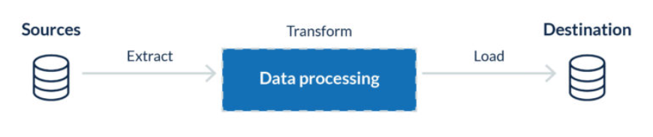

Here we create a scalable ETL pipeline which can extract data from multiple sources. For the transformation we create a standard date format which would be easy to query.

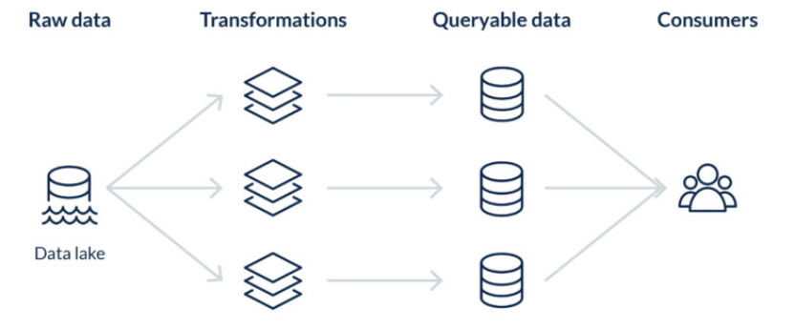

We take the raw data from the source extracted and apply transformations and enable the data to be queryable for the consumers.

This is a standard ETL pipeline where we transform data from multiple sources and convert them to transformed data from a single source ready for API consumption.